Rosenheim match report
Welcome to the first Rosenheim match report of 2022. A pleasant evening in Kingston welcomed a team of youth and experience, and there were a number of fantastic performances recorded. The evening started with three athletes in the 2km steeple chase, needing a photo finish to separate the two Walton athletes that came first and second. Jamie McLoughlin [M45] set a new M45 club record, clocking a time of 7.00.9 PB. Rob A Smith [SM] a close second with a big PB in 7.01.2, Chris Ness [M50] came home in 7.14.2, knocking 5 seconds off his M50 club record.
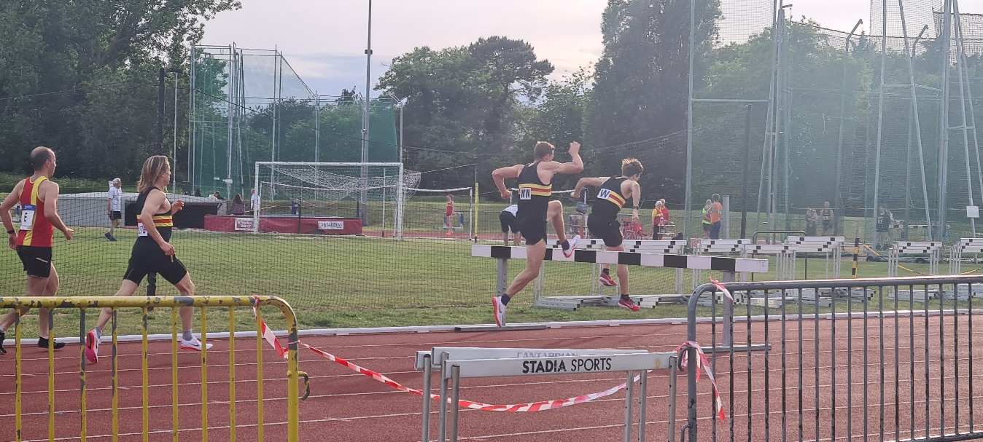
Billy Guest [U17] dipped under 12 seconds for the first time, running 11.9 PB in the first 100m heat and followed that up with 24.2 PB in his first 200m of the year. Stuart Channon [M45] clocked 12.00 to set a new M45 100m club record, and 24.6s in his 200m heat. Mike Futtit [M55] narrowly missed the M55 100m club record in clocking 15.10 PB, then threw 20.57m (1.5kg) & 16.82m (2kg) in the discus, and 21.07m in the Javelin. Martin Norman [SM] recorded a throw of 26.70m in Javelin to take top spot, then Rob and Chris both also competed in the long jump, Rob recording 5.03m SB and Chris 4.33m =SB.
Martin Willis [M45], Stuart Channon [M45], Billy Guest [U17] and Rob A Smith [SM] competed in the 4x200m relay, finishing second in 1.48.8 SB.
Hannah Giblin [U17] was a fraction away from her personal best in winning the 800m race (2.34.6), before Oluwatobu Aderoju [U17] finished 3rd in 14.6 SB in the 100m. Sophie Mace [SW] dominated the discus, throwing 45.47m.
Many great performances, club records and personal bests over the evening and hopefully there will be more of the same at the next match in Ewell 15 June 2022.

