SAL Final Match Report – Carshalton
Our final league match took us to the David Weir Leisure Centre, Carshalton to face some tough opposition, with the other team occupying the top half of the division table. Walton finished the match in 2nd Place with our highest points total for the 2022 season with 190pts, a mere 28pts behind host club Epsom [1st 218pts] and bettering Radley and Newbury [3rd 145pts and 4th 135pts respectively].
I could wax lyrically about this league match for several pages it was THAT good; with multiple personal bests, staggering victory margins, close to 30 1st place finishes across all events, and 5 athletes making the Man and Woman of the Match shortlists and 1 winner of the award – a simply phenomenal achievement and a great meet to bring the season to a close. The team support throughout the meet and especially at the end for the relays generated a phenomenal atmosphere and gave all athletes a truly wonderful competition experience to close the year. Picking out highlights and key performances has been a genuine struggle, as the day had so much to call out!
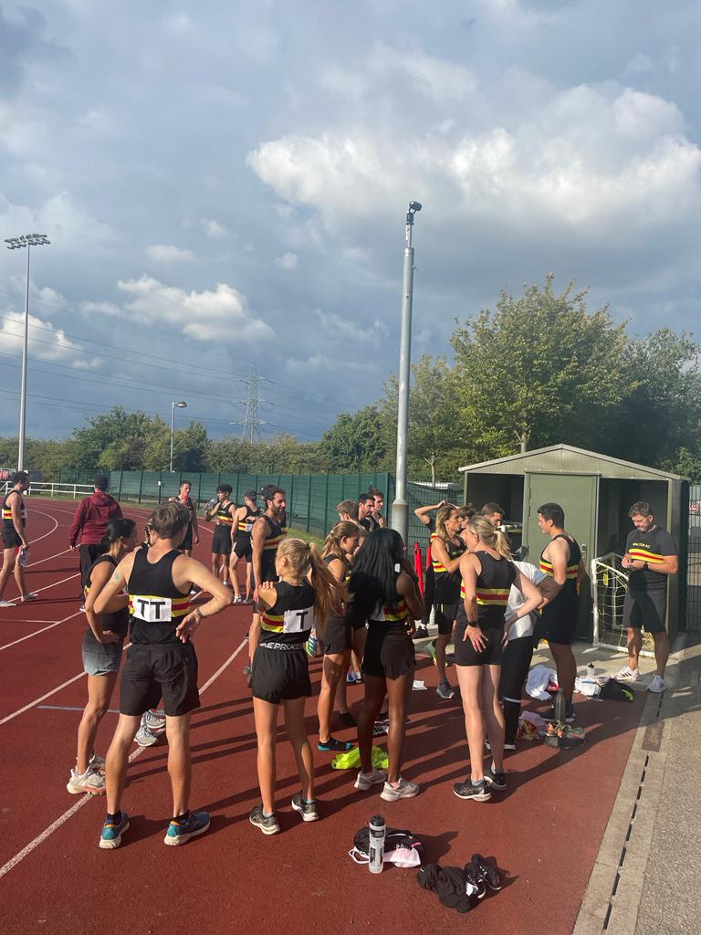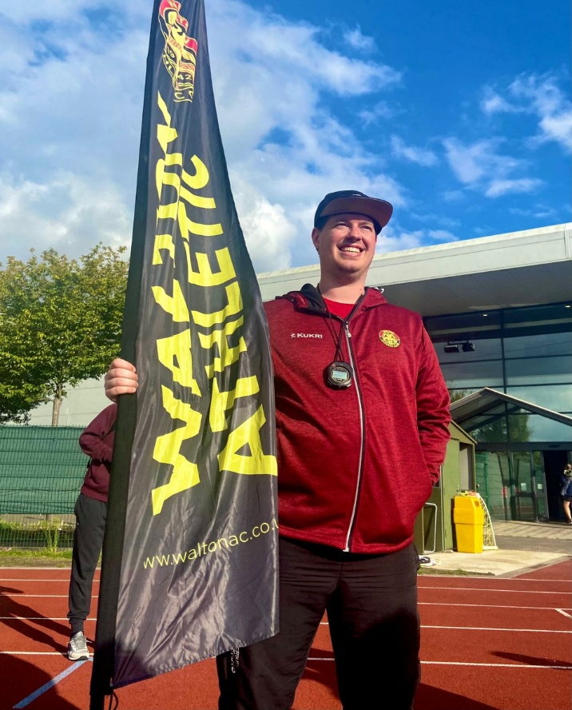
[The Team ready to cheer the relays on] [Team Manager M.Norman carrying the Team Flag]
With the Men, we dominated on the track and the throws, picking up double 1st place finishes in the 800m, 5000m, Discus, Hammer, and Javelin – well done to Jonathan Hiorns, Sam Foreman, Sam Mace, Rob C Smith, and Jeremy Hames!! We also picked up several 1st & 2nd place combos, such as the 400m, 1500m, 2000m Steeplechase, Pole Vault, Triple Jump, and Shot Putt – fantastic work and well done to Jonathan Hiorns, George Pittwood, Sam Foreman, Matt McKenna, Jamie McLoughlin, Robert A Smith, Jon Ladley, Chris Ness, Luc Balayer, Sam Mace, and Rob C Smith!! In terms of Performance Highlights – we need to make 5 callouts:
- Sam Mace – 11pts scored two 1sts and a 2nd place, however his win in the Men’s Hammer secured him with the Leagues Man of the Match award – the first time a Walton AC athlete has won it this season!
- Jonathan Hiorns – 12pts scored from three 1st place finishes, and was 2nd place for the Leagues Man of the Match Award, being pipped by Sam.
- Alex Kilby – 4pts score from his victory in the Mens 5000m A race in a new PB, and was 5th place for the Leagues Man of the Match Award.
- Robert A Smith – 23pts scored in another phenomenal multi-event masterclass and a fantastic contribution to the teams end of match score!
- The Men’s 4x400m Relay team – the quartet of Hiorns, Foreman, Pittwood [U17], and McKenna [U17] wished to underline their individual dominance with a real tour de force for the relay. Not only did they cross the line first with a 13s winning margin [otherwise known as a 90m lead] the time posted of 3:36.4 is the fastest Senior Men’s 4x400m performance since 2014, and the team had two U17’s present. Simply amazing!
Our Ladies were equally as impressive, with double 1st place finishes in the 800m courtesy of Hayley Cargill and Hannah Giblin, a duo of 1st & 2nd place finishes via the 400m and Triple Jump – well done to Hayley Cargill, Frida Blackwood, Evie Donaldson, and Tina Howell, and individual wins in the 1500m, 100m Hurdles, Discus, and Javelin – congratulations to Hayley Cargill, Lucy Bartlett, Oluwatobi Aderoju, and Nicola Bell. In terms of Performance Highlights – we need to make the following callouts:
- Hayley Cargill – 16pts score from three wins [400m, 800m, 1500m] and two 3rd place finishes from the relays, and 5th place for the Leagues Woman of the Match award.
- Nicola Bell – 7pts scored from the three throwing disciplines [1st Javelin, 3rd Discus, 4th Shot Putt], and was 4th place for the Leagues Woman of the Match award.
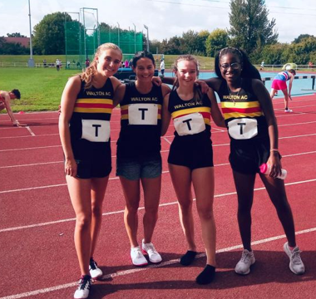
[Our Women’s 4x100m Team (L-R: F.Blackwood, H.Cargill, E.Donaldson, and O.Aderoju]
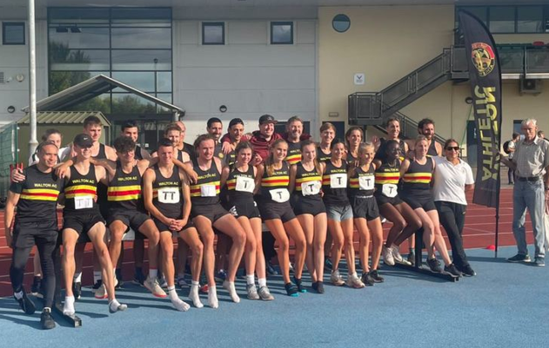
A truly wonderful day of athletics, and it was amazing to see so many athletes stay for the relay, cheering the team’s home to some great performances.
As always, we could not have done this meet without our team of volunteers – a special note of appreciation to Clint Marks, Sabrina Mace, Jonelle Salter, Robin Roach, and Paul Edwards.
I wish everyone a happy and injury free winter – and I look forward to working with you all again next season.
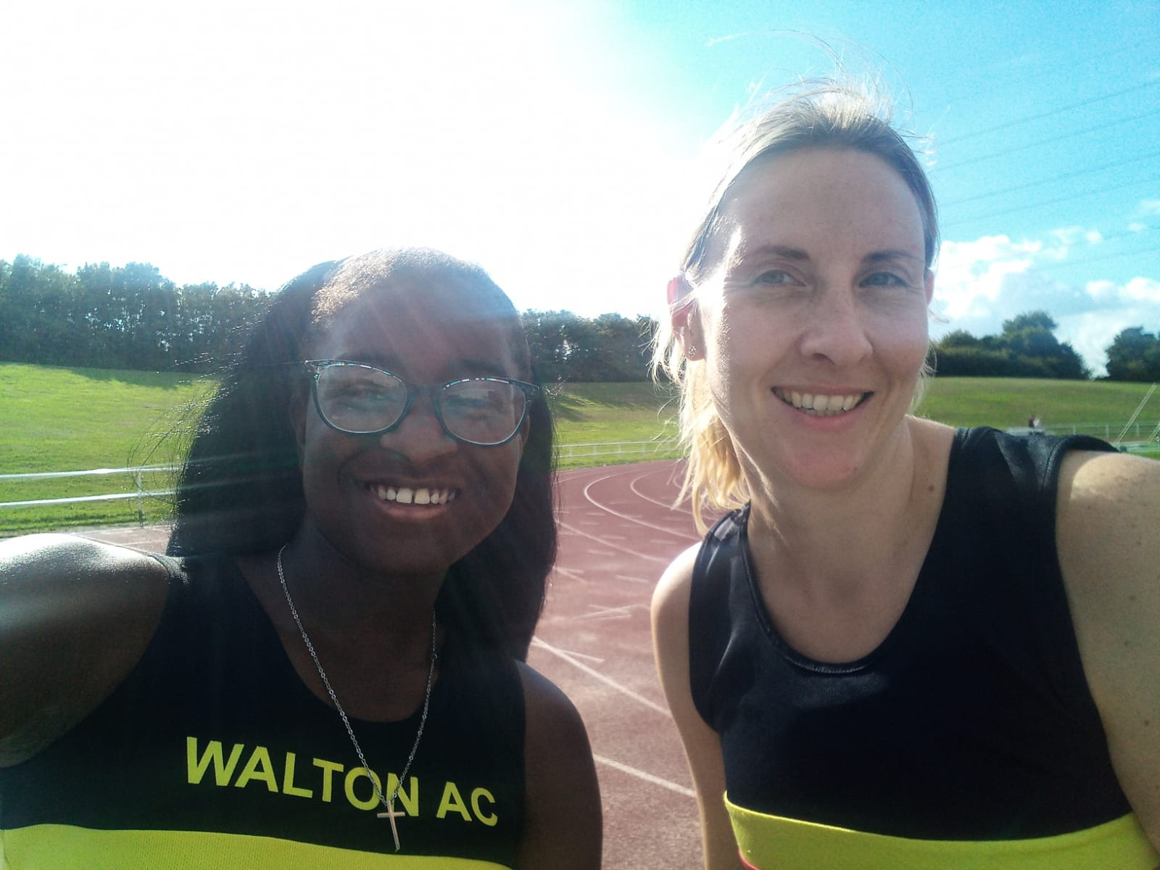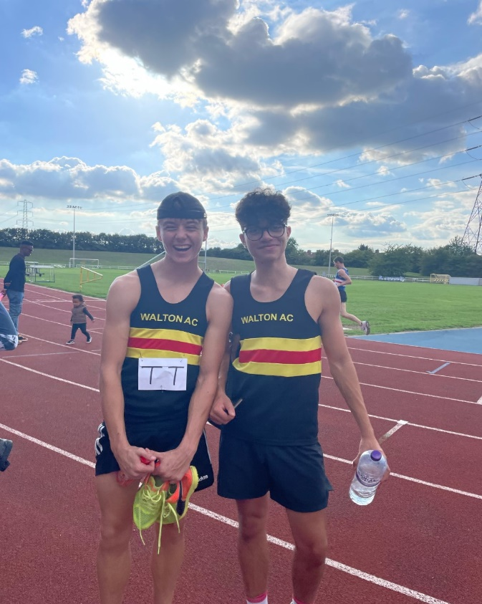
[End of Match smiles from O.Aderoju, T.Howell, M.McKenna, and S.Salter]
Martin Norman
SAL Team Manager

